MINDFULNESS for STRESS
AUTUMN 2021 course
Learn lasting skills to cope with the effects of the ever-changing world in which we are now living in since Covid 19
Starting 19th October – 14th December 2021
Tuesday evenings 6pm – 8pm
On line via zoom
If you tend to suffer from stress, anxiety, depression or are living with a chronic health condition, this course will help empower you to become more resilient, calmer, self-compassionate and happier in your day to day life. The course is both practical and theoretical and will give you coping skills to change your reactions to stress and improve your quality of life for the better.
Run by Nikki Jackson, a UK fully accredited Mindfulness Teacher and Coach with 30 years professional experience in stress management in NHS and private sector. Also Director of 550 hr Teacher training in Yoga Therapy which uses Mindfulness based practises
For further information regarding this course please visit:
https://www.breathworks-mindfulness.org.uk/mindfulness-for-stress/course-overview
And for bookings :
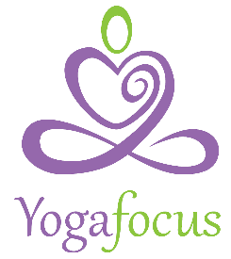
Nikki Jackson
Nikki@yogafocus.co.uk
www.yogafocus.co.uk

